ACG proceedings style template

Jane Smith a,[1], Tom Johnson b, Brad Jones b,c

*a Department Name or Mine Site (optional), Company Name, Country*

*b BHP, Australia*

*c Australian Centre for Geomechanics, The University of Western Australia, Australia*

# Abstract

The abstract is to provide a general scope of the work and applications. Please limit the abstract to approximately 300 words.

Please add the corresponding author’s details to the footnote of the first page as per the example footnote on this page.

**Keywords:** please insert keywords in italics, lower case first letter, no full stop at the end

# Introduction (to using this style template)

Please note that the styles are locked in this template document, however, all styles that are necessary for you to format and draft your paper should still be available in the Styles Library. The styles are listed alphabetically, except for the last few. We have tried to create all the styles that you will need, so please check the library before contacting the ACG with a query.

Please ensure your settings are as indicated in Figure 1 in order to access the ACG proceedings styles.

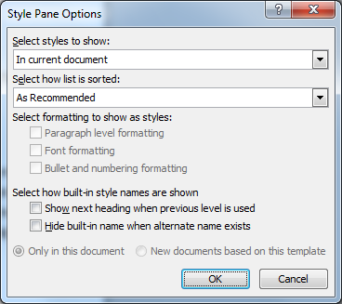

Figure 1 Settings required to use the ACG Style Library. Please note that images used within your paper must be of high quality, resizable, relevant, and referred to within the text. Also Figure captions must be sentence case, with no full stop at the end

Please setup your document as A4 and the page margins as shown in Figure 2. Please ensure all figures and tables are cited within the text in the paragraph before the figure, as shown in this document.

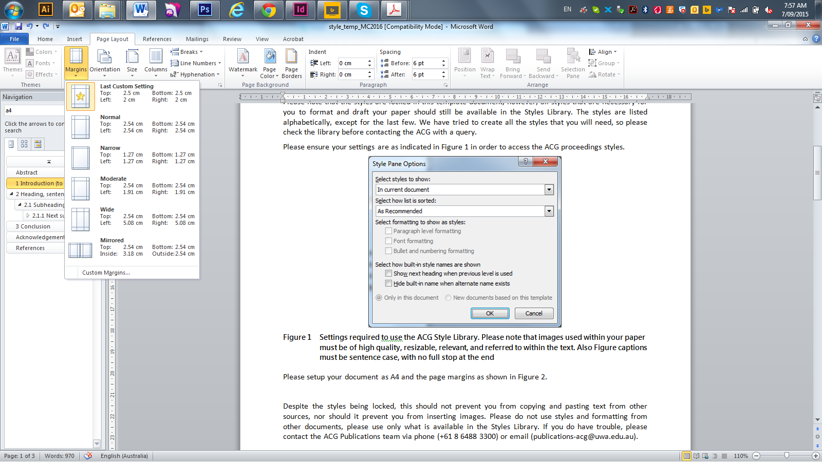

Figure 2 Proceedings margin format; Top/Bottom margins at 2.5 cm and Left/Right margins at 2 cm

Despite the styles being locked, this should not prevent you from copying and pasting text from other sources, nor should it prevent you from inserting images. Please do not use styles and formatting from other documents, please use only what is available in the Styles Library. If you do have trouble, please contact the ACG Publications team via phone (+61 8 6488 3300) or email ([publications-acg@uwa.edu.au](mailto:publications-acg@uwa.edu.au)).

 

(a) (b)

Figure 3 Figures comprised of two or more images should be labelled as per this example. (a) Settings required to use the ACG Style Library; (b) Proceedings margin format

# Heading, sentence case

Paragraphs of text. Each heading needs to be followed by a paragraph of text before inserting tables, figures or bullets and should include any relevant figure/table citations.

## Subheading, all headings must be numbered

Table 1 Rules for tables use. Table caption, sentence case, no full stop at the end

|  |  |
| --- | --- |
| Heading | Heading and heading or heading |
| Table widths will be adjusted as necessary and content will be realigned (left, centre, right) as required. Tables must be centred on page | The only borders allowed are top and bottom edges, plus under the ‘heading’ rows |
| Columns can be as wide as needed to fit the data | Text size should be consistent within the table, the styles should be used |
| If a table is large it can be on a landscape page | Try to avoid merging cells unless it is necessary |
| Each line of new data should be entered into a new row/cell, not listed within one cell | Tables and figures are numbered according to the order in which they are inserted into the paper, not according to paper sections |
| It is preferable that images of tables are not used and tables are editable such as this one | Use hyphens without spaces before/after  10-20 mm, 1,000-10,500 kg, 1-6 May 2014 |
| – | Use “–“ (en dash) when the cell is empty |

Paragraphs of text. Ut et quatibus sanda dolor reribus, iumquistius modi repratur, eos res magnation re veligendit quia comnime ndiaspelent di ut od quunt.

(Please use bullet points judiciously)

* Bullet examples.
* Bullet examples:
* Sub-bullet example.
* Bullet examples.

Text:

1. Step 1: this proves to be….
2. Part a: this proves to be ….
3. Part b:
4. Step 2:

## Second level heading

Paragraphs of text. Ignatia tiorerumque natis aut odis di cum as sus rehent hiciet et experspis exceseritam, sam exerum idigent.

## Next second level heading

Paragraphs of text. Nem volores vendam nis de most veligni squiam aut aut estiasim rero debit latur aperum velit volum, simusdae ad eatquidi tectatem quas accaerum quat pa quis aut vendus, et velit omnihillut odiossit as re non oluptatur, incia sitae latatem ex et que estio doluptum re esciunt res conectiumque accum as eossum, sequi volendest volupti orumqui omnienim veruptiunte quae doloribus explit, ommoluptate pe repe sim quam inim sunt.

‘Quoted text (longer than a few words) should be set like this so that it stands out from the body of the text. A reference citation should be provided at the end.’ de la Vergne (2003)

Single ‘apostrophes’ should be used to emphasise a term; not italics/bold.

### Third level heading

Paragraphs of text. Ehenimus sit, nonserum, sint hitatectur sitae laccati int aut autempe liquis non etum quiaeperit, simuscia dolut pratur? Lest experum fuga. Fugit voloreped unt lacesti aturibusam et dolorit harum fugiam aditati dolupta sam nimin nos eaquatur, aut volorepro doluptia veles nese voluptatur, incia sitae latatem ex et que estio doluptum re esciunt res conectiumque accum as eossum, sequi volendest volupti (Christian et al. 1993):

 (1)

where:

Ch = each element introduced in an equation must be explained directly after that equation.

# Conclusion

No new information should be introduced within a conclusion, nor should Figures or Tables be inserted.

# Acknowledgement (do not number this heading)

Feel free to acknowledge whoever is necessary.

# References (do not number this heading)

Listed references should be cited within the paper, and alternatively all citations must have references listed, authors will be notified if citations or references are missing, please follow the Author's Guidelines on how to format your references correctly or refer to our [online reference generator](https://papers.acg.uwa.edu.au/referencing).

Christian, J, Ladd, C & Baecher, G 1993, ‘Reliability applied to slope stability analysis’, *Journal of Geotechnical Engineering*, vol. 120, no. 12, pp. 2180–2207.

de la Vergne, J 2003, *Hard Rock Miner’s Handbook*, McIntosh Engineering, North Bay, Ontario, viewed 3 March 2014, http://www.altomines.com/pdfs/HardRockMinersHandbook.pdf

Kuganathan, K 2005, ‘Geomechanics of Mine Fill’, in Y Potvin, E Thomas & A Fourie (eds), *Handbook on Mine Fill*, Australian Centre for Geomechanics, Perth.

Potvin, YH & Wesseloo, J 2013, ‘Towards an understanding of dynamic demand on ground support’, in Y Potvin & B Brady (eds), *Proceedings of the Seventh International Symposium on Ground Support in Mining and Underground Construction*, Australian Centre for Geomechanics, Perth, pp. 287–304.

1. Corresponding author. Email address: [jane.smith@emailaddress.edu.au](mailto:jane.smith@emailaddress.edu.au) (email address is optional)